Task 1
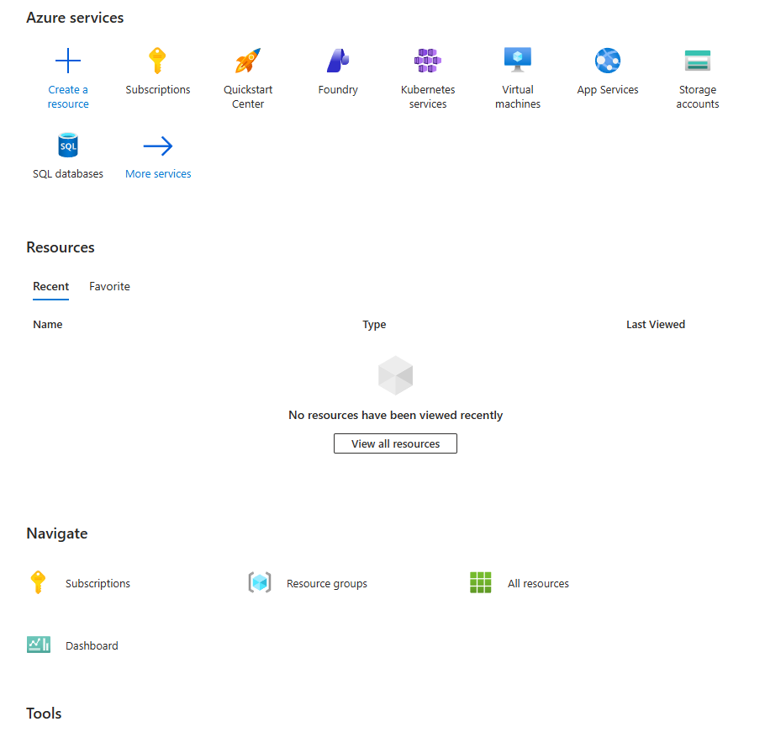

Task 2
Type of Organisation
CTU Training Solutions is a private education provider that operates in the training and higher education sector. It can be seen as a medium to large organisation because it has multiple campuses and offers both in-person and online courses. Its main goal is to provide students with practical skills and qualifications, especially in IT and business-related fields.

2. Main IT Needs of the Organisation
CTU relies heavily on IT systems to run its daily operations. First, it needs systems to manage a large number of students, lecturers, and admin staff. It also requires an online learning platform where students can access notes, submit assignments, and attend classes remotely.
Another important need is data storage, as the organisation must store student records, results, and course material securely. CTU also uses different applications such as email systems and collaboration tools for communication. On top of that, it needs a reliable network and backup system to make sure data is not lost and services are always available.

3. Why Cloud (Azure) is Better than On-Premises
Using a cloud platform like Microsoft Azure is more beneficial than having physical servers on-site. One reason is scalability, because CTU can increase or decrease resources depending on how many students are using the system.
It is also more cost-effective, since the organisation does not need to buy and maintain expensive hardware. Another benefit is accessibility, as students and staff can log in from anywhere, which is important for online learning. Cloud systems also offer better reliability and backup options, reducing the risk of downtime or data loss.

4. Security and Compliance Requirements
CTU must make sure that all student and staff information is kept safe. This includes using secure login systems and making sure only authorised people can access certain data. Data should also be encrypted to protect it from hackers.
The organisation must follow South African laws such as the POPIA, which focuses on protecting personal information. Regular monitoring and security checks are also important to detect any possible threats.

5. Expected Number of Users
The system should be able to handle a large number of users at the same time. This includes thousands of students, as well as lecturers and administrative staff.
A reasonable estimate would be around 2,000 to 10,000 students, 200 to 500 staff members, and a smaller group of IT administrators. Because of this, the system must be designed to handle high usage, especially during busy times like exams or assignment deadlines.

DECLARATION OF AUTHENTICITY

I Ian Strauss (FULL NAME) hereby declare that the contents of
this assessment NET731 is entirely my own work, withthe exception of the following items listed below.

Signature : 

Date : 2026/04/13

Microsoft (2024) What is Azure? Available at: https://azure.microsoft.com/en-us/resources/cloud-computing-dictionary/what-is-azure/
Microsoft (2024) Azure security documentation. Available at: https://learn.microsoft.com/en-us/azure/security/
Republic of South Africa Government (2013) Protection of Personal Information Act (POPIA). Available at: https://www.gov.za/documents/protection-personal-information-act
IBM (2023) What is cloud computing? Available at: https://www.ibm.com/topics/cloud-computing
Amazon Web Services (2024) Overview of cloud computing. Available at: https://aws.amazon.com/what-is-cloud-computing/
Task 3
Azure Service | Purpose / Why you need it | Week it is used
Resource Group | A resource group is used to organise and manage all Azure resources in one place. It makes it easier to control, monitor, and delete resources as a group. | Week 1
Virtual Network (VNet) | The VNet allows secure communication between Azure resources. It acts like a private network in the cloud where services can connect safely. | Week 2
Virtual Machine (VM – B1s) | The VM is used to run applications and simulate a real server environment. The B1s size is cost-effective and suitable for basic workloads. | Week 3
Microsoft Entra ID | Microsoft Entra ID is used to manage user identities and control access to resources. It ensures only authorised users can log in. | Week 1
Network Security Group (NSG) | NSG is used to control incoming and outgoing traffic to resources. It helps protect the network by allowing or blocking specific traffic. | Week 2
Azure Storage Account | This service is used to store data such as files, backups, and logs securely in the cloud. It is reliable and scalable. | Week 4
Microsoft Defender for Cloud | Microsoft Defender for Cloud helps monitor security and detect threats. It gives recommendations to improve security. | Week 5
Azure Monitor | Azure Monitor is used to trac

Task 4
